EXPERIMENT – 7

EXP No: 7

Date: ___________

Title
GROUP BY, HAVING and ORDER BY Clauses

AIM
To perform GROUP BY, HAVING, and ORDER BY operations on the Drone Delivery Management System database.

DESCRIPTION
- GROUP BY groups rows with the same values.
- HAVING filters grouped records.
- ORDER BY sorts records in ascending or descending order.

PROCEDURE
- Open MySQL Command Line.
- Select the DroneDelivery database.
- Execute GROUP BY queries.
- Apply HAVING clause.
- Sort the records using ORDER BY.

Query 1

USE DroneDelivery;



Query 2

SELECT DroneStatus,

COUNT(*) AS TotalDrones

FROM Drones

GROUP BY DroneStatus;

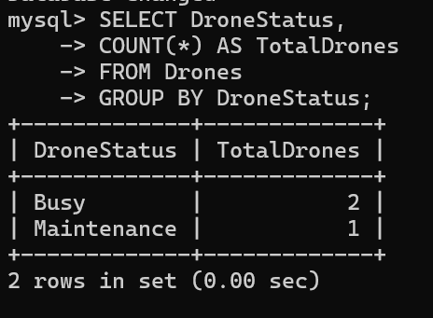

Query 3

SELECT DeliveryStatus,

COUNT(*) AS TotalDeliveries

FROM Deliveries

GROUP BY DeliveryStatus;

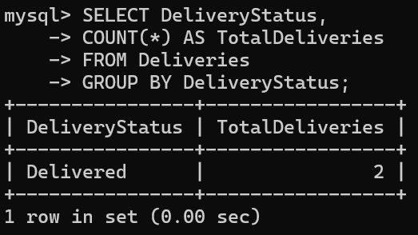

Query 4

SELECT Address,

COUNT(*) AS Customers

FROM Customers

GROUP BY Address;

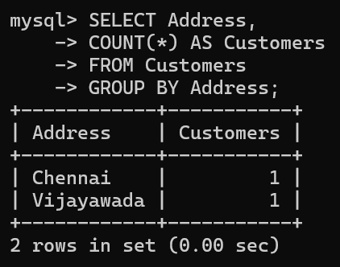

Query 5

SELECT DeliveryStatus,

COUNT(*) AS TotalDeliveries

FROM Deliveries

GROUP BY DeliveryStatus

HAVING COUNT(*) >= 1;

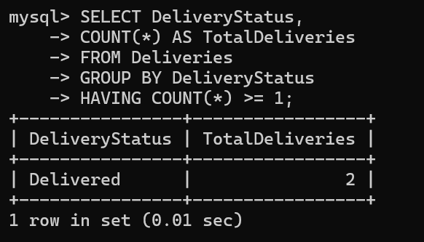

Query 6

SELECT *

FROM Customers

ORDER BY CustomerName ASC;

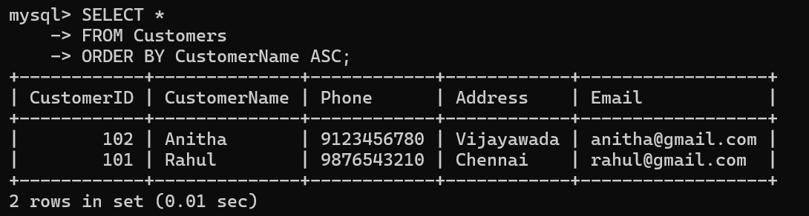

Query 7

SELECT *

FROM Drones

ORDER BY PayloadCapacity DESC;

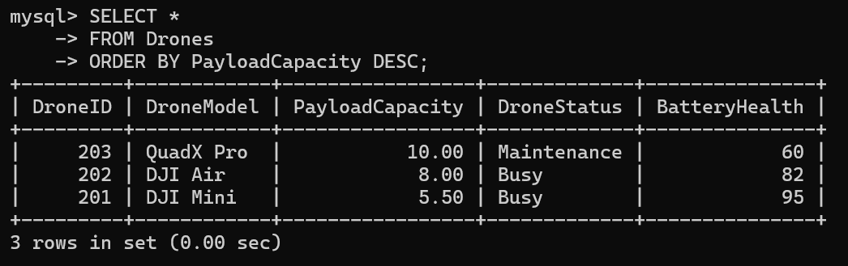

Query 8

SELECT *

FROM Deliveries

ORDER BY DeliveryDate DESC;

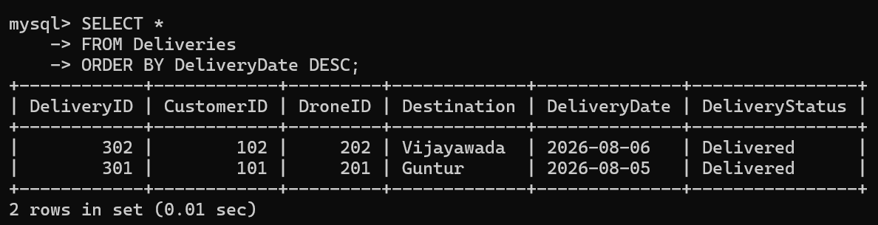

Query 9

SELECT *

FROM Customers

ORDER BY CustomerID;

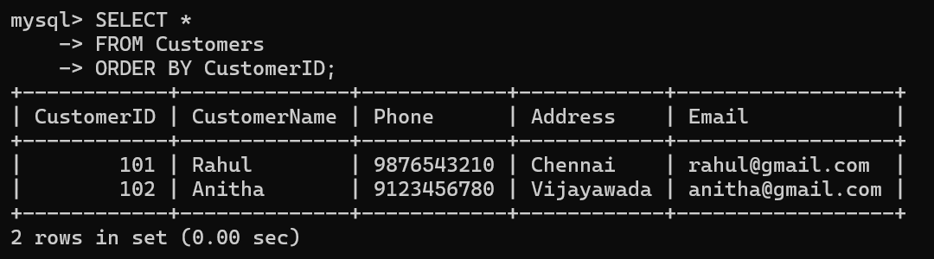

Query 10

SELECT Destination,

COUNT(*) AS TotalOrders

FROM Deliveries

GROUP BY Destination;

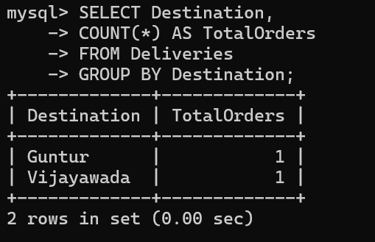

RESULT
Thus, the GROUP BY, HAVING, and ORDER BY clauses were successfully executed on the Drone Delivery Management System database.

